HW: 2.9 Solving Systems of Non-linear systems Algebra 2 Kitt
Name:________________________________________________Date:_________________________Period:_____
Directions: Solve the following systems algebraically.
- $\begin{matrix}y=x \\ y=x^{2}-2\end{matrix}$ 2. $\begin{matrix}y=-x+1 \\ y=x^{2}+5x+6\end{matrix}$ 3. $\begin{matrix}y=x^{2}+4x-1 \\ y=x-3\end{matrix}$

Directions: Solve the following systems by graphing.

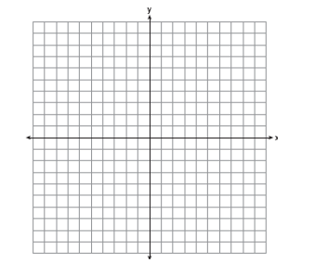
4. $\begin{matrix}y={(x-2)}^{2}-9 \\ y=x-1\end{matrix}$ 5. $\begin{matrix}y={(x+2)}^{2}+2 \\ y=2x-6\end{matrix}$ 6. $\begin{matrix}y={(x+1)}^{2}-2 \\ y=3x+5\end{matrix}$

