**ALGEBRA 2** Name _________________________ Block ____

Unit 4, Test 1 Review

**Rational Exponents**

1. **Rewrite** the following using rational exponent notation.
   1. 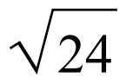
   2. 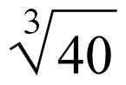
   3. 

d) 

1. **Rewrite** using radical notation. (2 each)
   1. 
   2. 
   3. 
2. **Evaluate** the expression: No negative Exponents!
   1. () =

b. 16 =

* 1. 4 =

4) Find the compositions of given values if: Let   

1. $f(g\left(3\right))$**b) $h(f\left(-1\right))$**

**c) $g(g\left(x\right))$ d) $f(h\left(x\right))$**

1. Find the equation of the inverse relation, then determine if the inverse is a function:

a)  b) ; $x≥0$ c) 

Function: Yes or No Function: Yes or No Function: Yes or No

D: ______________ D: ______________ D: ______________

R: ______________ R: ______________ R: ______________

6) Name the domain and range of each graph using interval notation.

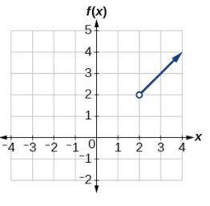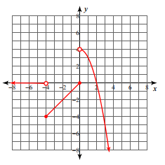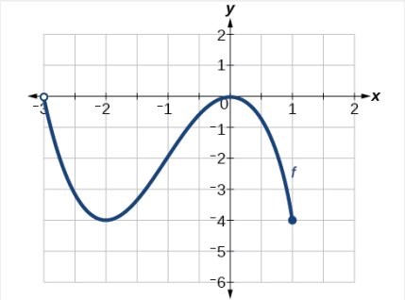 a. b. c.

D: _________________ D: __________________ D: ________________

R: _________________ R: __________________ R: ________________

7) Circle the expression that does **not** belong in a group with the other three? Justify your reasoning, including any necessary to work to support the explanation. ( a little tricky ☺)

a) b) c) d)

8) Simplify: No negative exponents!

1. b)

c) d)

9) For and $g\left(x\right)={\left(x\right)}^{5/2}$ answer the following making sure to show all work.

$a) f\left(x\right)-g\left(x\right)$ b) $f\left(x\right)+g(x)$ c) $f(x)∙g(x)$

|  |  |  |  |  |  |
| --- | --- | --- | --- | --- | --- |
| $$x$$ | 0 | 1 | 2 | 3 | 4 |
| $$y$$ | -8 | -1 | 0 | 1 | 8 |

$10) f\left(x\right)={\left(x-2\right)}^{3}$ is shown in the table alongside.

Is the inverse of $f\left(x\right)$ a function?____________ Why/why not?

11) Use composition of functions to decide if $f\left(x\right) and g\left(x\right)$ are inverse functions. Show work to prove your answer.

12) For and answer the following making sure to show all work.

b) c)