3.5 Writing Equations in Polynomial Functions (Part 3)

Name:______________________________________________________Date:_____________________Period:_______

**Directions**: Write an equation of the following polynomial. You may leave it **in factored form**

1)

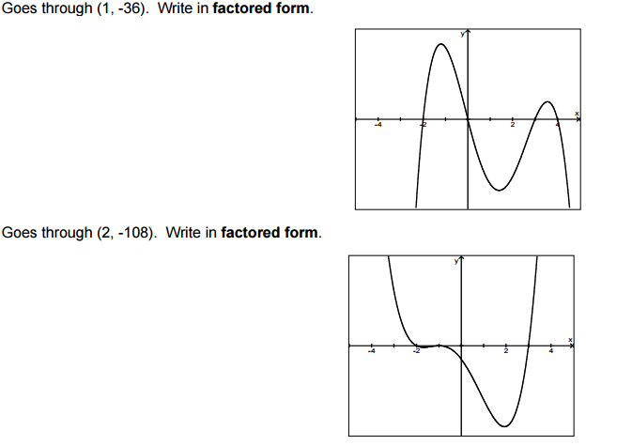



2)

3) Goes through (0,2). Write in factored form.

**Directions**: Sketch the graph of each function.

4) f(x) = (x + 1)(x – 2)(x – 4)

5) f(x) = -(x + 3)(x + 2)(x – 1)3

6) f(x) = -x(x + 5)2(x + 3)

7)

8)

9) Write a possible equation for a polynomial with a degree of 6 and having 5 as a triple root, -2 as a double root, and 3 as a single root (in factored form).

10) Write a possible equation for a polynomial with a negative leading coefficient and an even degree (in factored form).