Homework: 4.2 Operations of Radicals Algebra 2 Kitt
Name:_______________________________________________Date:___________________________Period:_______
Directions: Perform the following operations and simplify all radicals.
- $3\sqrt{5}+4\sqrt{5}$ 2. $2\sqrt{7}+7\sqrt{2}$ 3. $14\sqrt{8}-5\sqrt{8}$

4. $2\sqrt{11}+7\sqrt{11}-4\sqrt{11}$ 5. $7\sqrt{6}+4\sqrt{3}-3\sqrt{6}+2\sqrt{2}$ 6. $\sqrt{8}+\sqrt{18}$

7. $\sqrt{75}-\sqrt{20}$ 8. $\sqrt{27}-\sqrt{48}-2$ 9. $-5\sqrt{44}+2\sqrt{99}$

10. $3\sqrt{72}+2\sqrt{75}-3\sqrt{27}+\sqrt{108}$

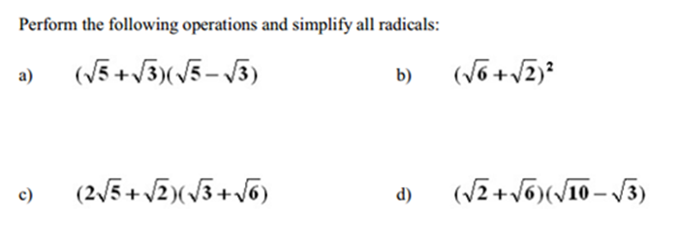

e) $\frac{\sqrt{2}}{1+\sqrt{3}}$ f) $\frac{\sqrt{3}}{1-\sqrt{5}}$ g) $\frac{\sqrt{5}}{5+\sqrt{2}}$

