Homework 6.1 Graphing Systems of Equations Algebra 1 Kitt
Name:______________________________________________Date:______________________________Period:______
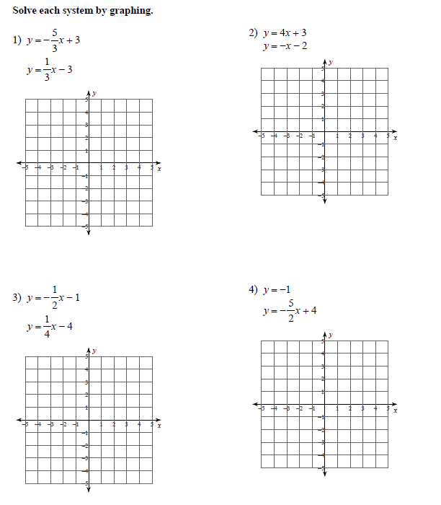
What are the three types of solutions for graphing systems of linear equations?
1.
2.
3.

Directions: Solve each system by graphing.
