CW: Factoring Polynomials Algebra 1 Kitt
Name:_____________________________________________Date:______________________________Period:_______

Directions: Use a separate sheet of paper to show work on all of these factoring problems.

- Backwards Distribution
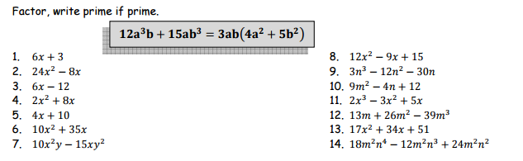
- Factoring Differences of Squares
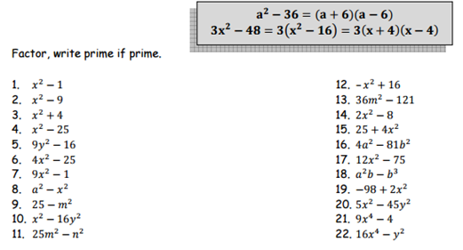
- Factoring Trinomials.
