Name: ________________________________________ Algebra 2 Fall Final Exam Review
1. Linear Applications
a. Kim and Cyndi are starting a business tutoring students in math. They rent an office for $400 per month and charge $40 per hour per student. Write an equation to represent their profit. Then find their profit for a single month if they have 15 students for one hour per week? (Assume 4 weeks per month)

b. To fix Ms. Dukes’s car, Bob’s Bumper Repair charges a flat fee of $40 plus $45 per hour.
i) Write an algebraic equation using C for the cost and h for the number or hours.
ii) How much would it cost to repair the car if it took 8 hours to complete?

c. A tree 5 feet tall grows an average of 6 inches each year.
i) Write and graph a linear equation to model the tree’s height (in feet) as a function of time (in years).
ii) How tall will the tree be in 20 years?

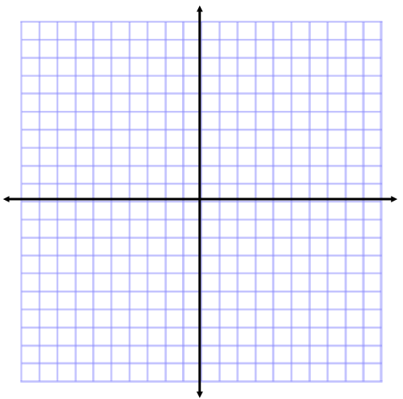
2. Graphing Absolute Value Functions
a. Given the function $f\left(x\right)=-\left|x+2\right|-1$
i. What is the vertex?
ii. Opens: Up or Down (circle answer)
iii. Stretched/Compressed/Neither
iv. Graph the function

b. Given the function $f\left(x\right)=2\left|x+4\right|+5$
i. What is the vertex?
ii. Opens: Up or Down (circle answer)
iii. Stretched/Compressed/Neither
iv. Graph the function
c. Given the function $f\left(x\right)=\left|x\right|+1$
i. What is the vertex?
ii. Opens up or down (circle answer)
iii. Stretched/Compressed/Neither
iv. Graph the function

3. Solve the System of Equations by Graphing
a. $\begin{matrix}-2x+y=3 \\ y=-5x-4\end{matrix}$ b. $\begin{matrix}4x+y=1 \\ x+y=-2\end{matrix}$ c. $\begin{matrix}y=\frac{1}{2}x-2 \\ -3x+6y=12\end{matrix}$
.

4. Use either Substitution or Elimination to solve the following system of equations.

a. $\begin{matrix}-3x-4y=2 \\ 3x+3y=-3\end{matrix}$ b. $\begin{matrix}y=5x-7 \\ -3x-2y=-12\end{matrix}$ c. $\begin{matrix}-4x+y=6 \\ -5x-y=21\end{matrix}$

5. Graph the inequality.
a. $y≤\frac{1}{2}x-3$ b. $2x-3y≥9$ c. $y<-5x+1$

6. Graphing Quadratic Functions
a. Graph the function: $y={-(x+4)}^{2}+5$
i. What is the vertex?
ii. What is the y-intercept?
iii. Stretched/Compress/Neither (circle one).

b. Graph the function: $y=(x+5)(x+9)$
i. What is the vertex?
ii. What is the y-intercept?
iii. Stretched/Compress/Neither (circle one).

c. Graph the function: $y=x^{2}-3$
i. What is the vertex?
ii. What is the y-intercept?
iii. Stretched/Compress/Neither (circle one).

7. Quadratic Applications- Maximum/Minimum/Zeroes
a. A rocket carrying fireworks is launched from a hill 80 feet above a lake. The rocket will fall into the lake after exploding at its maximum height. The rocket’s height above the surface of the lake is given by the function $h\left(t\right)=-16t^{2}+64t+80$. What is the maximum height reached by the rocket? When does the rocket hit the ground?

b. A small business’ profits over the last year have been related to the price of the only product. The relationship is $R\left(p\right)=-0.4p^{2}+64p-2400$ where $R$ is the revenue measured in thousands of dollars and $p$ is the price of the product measured in dollars. What price would maximize the profit?

c. A ball is thrown and follows the path described by the function $h\left(t\right)=-5t^{2}+20t+1$, where $h$ is the height of the ball and $t$ is the time since the ball was released. How long does it take for the ball to reach its maximum height? When does the ball hit the ground?

8. Solve the equations by factoring:
- v² – 18 = -3v b) 5n² + 31n + 30 = 0 c) ${6x}^{2}-10x-4=0$

9. Solve the equations with the quadratic formula:
a) 2k² – 4k – 16 = 0 b) r² + 5r + 24 = 0 c) 5v² +10v – 3 = 0

10. Simplify the expressions:
- (3 – 7i) + (-2 + 3i) b) (8 + 6i) - (-1 – i) c) (7 – 3i)(-4 – 8i)

11. Simplify the expressions:
- (2x⁴ + 5) – (3x⁴ – 1) b) (2x³ + 5x⁴) + (3x⁴ + x³) c) (6 – 2n²) + (4n – 14n² + 11)

12. Simplify the expression: (8m⁴n³ + 4) – (-12 + 8m²n³ + 14m⁴n³) + (14m²n³ – 13)

13. Find the Product:
- 5r (7r + 4) b) (6v – 5) (3v + 5) c) (7x² + 3x + 1)(4x – 3)

14. Use long division to simplify:
- $\left(3x^{2}-11x-26\right)÷(2x-5)$ b) $\left(7x^{3}+11x^{2}+7x+5\right)÷\left(x^{2}+1\right)$ c) $\frac{x^{2}+x-17}{x-4}$

15. Use synthetic division to simplify:
- $\left(2x^{2}-7x+10\right)÷(x-5)$ b) $\frac{x^{4}-5x^{3}-8x^{2}+13x-12}{x-6}$ c) $\left(x^{3}-5x^{2}-2\right)÷\left(x-4\right)$

16. Factor the following:
- $x^{3}+64$ b) $125n^{3}-27$ c) $27a^{3}-1000$

d) $x^{3}-3x^{2}-16x+48$ e) $x^{3}+7x^{2}-9x-63$ f) $g^{3}+3g^{2}-g-3$

17. Solve the following:
a) $x^{3}+2x^{2}-25x-50=0$ b) ${3x}^{3}-27x=0$ c) $n^{4}+6n^{3}=0$

d) $16g^{2}-625=0$ e) $3x^{3}+15x^{2}-18x=0$ d) $x^{3}-25x=0$

18. Solve the following systems either by algebraically or by graphing:
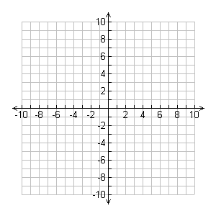
a) $\begin{matrix}y=-3x^{2}+3 \\ y=x+3\end{matrix}$ b) $\begin{matrix}y=x^{2}-4x+6 \\ y=x+2\end{matrix}$ c) $\begin{matrix}y=x^{2}+8x+16 \\ y=x+6\end{matrix}$

19. Find the average rate of change of the following:
a) Find the average rate of change from b) Find the average rate of change from
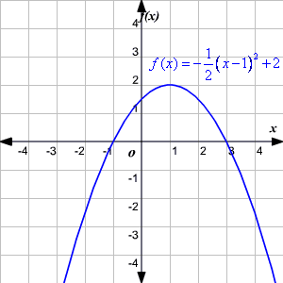
$x=2$ to $x=5$ $x=-1$ to $x=1$
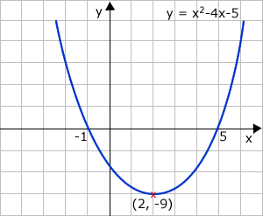

c) Find the average rate of change from $x=0$ to $x=2$
$$x$$ | $$f(x)$$
0 | 5
1 | 1
2 | -3
3 | -7
4 | -11

