Name: Block: Date:

Recursive and Explicit Formulas

1) Write the equation of the line that goes through the points in the table, in both explicit and recursive form.

$$x$$ | 1 | 2 | 3
$$f(x)$$ | 14 | 12 | 10

2) Write the equation of the line that is graphed below.
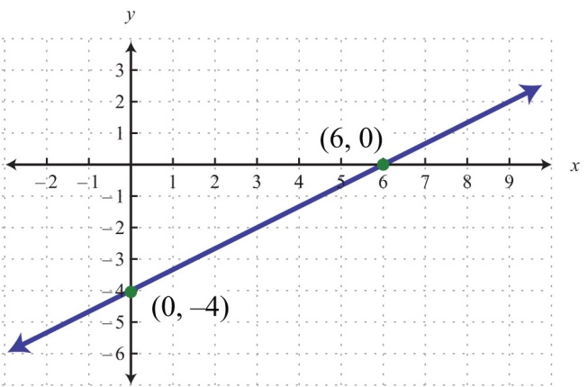

3) Convert the recursive form into explicit form for the equation: $\begin{matrix}y_{0}=14 \\ y_{n}=y_{n-1}-3\end{matrix}$

