Homework: 1.8 Substitution and Elimination Algebra 2 Kitt
Name:______________________________________________Date:___________________________Period:_______
Directions: Solve each system of equations using substitution. Show your work. Check your answers.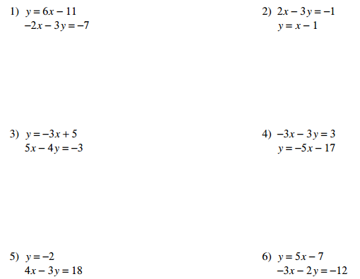

Directions: Solve each system of equations using elimination. Show your work. Check your answers.

