Homework: 5.1 Solving Logarithms/Exponentials with Common Bases Algebra 2 Kitt
Name:_________________________________________________________Date:__________________Period:_______
Directions: Rewrite each equation in exponential form.
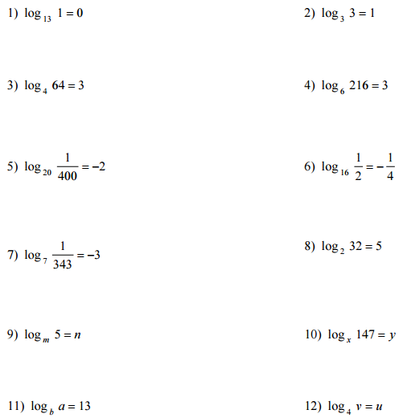
Directions: Rewrite each equation in logarithmic form.

Directions: Evaluate each expression.
