Homework: 5.5 Graphing Exponential and Logarithmic Equations Algebra 2 Kitt
Name:__________________________________________Date:____________________________________Period:_____

Directions: Graph each exponential and logarithmic function. Provide the following information that accompanies each graph.

- $y=2^{x+1}$ 2. $y=4^{x-1}$
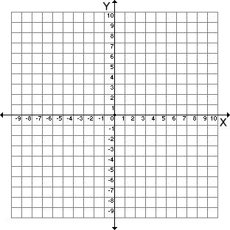
Asymptote:________ Asymptote:________

Domain:__________ Domain:__________

Range:___________ Range:__________

- $y=2^{x}+2$ 4. $y=2^{x-1}+3$
Asymptote:________ Asymptote:________

Domain:__________ Domain:__________

Range:___________ Range:__________

- $y=3^{x+5}-4$ 6. $y={-2}^{x}$
Asymptote:________ Asymptote:________

Domain:__________ Domain:__________

Range:___________ Range:__________

- $y=\log{(x+1)}$ 8. $y={\log\left(x-2\right)}^{ }+1$
Asymptote:________ Asymptote:________

Domain:__________ Domain:__________

Range:___________ Range:__________

- $y=\log\left(x\right)+3$ 10. $y=\log\left(x-4\right)-2$
Asymptote:________ Asymptote:________

Domain:__________ Domain:__________

Range:___________ Range:__________

- $y=\log{(x+6)}-1$ 12. $y=-log⁡(x)$
Asymptote:________ Asymptote:________

Domain:__________ Domain:__________

Range:___________ Range:__________

- $y=\ln{(x)}$ 14. $y=e^{x}$
Asymptote:________ Asymptote:________

Domain:__________ Domain:__________

Range:___________ Range:__________

