HW: 7.3 Analyzing Data Algebra 2 Kitt
Name: _______________________________________________Date: ____________________Period: _____

Directions: Provide the necessary information for each problem.

- A high school basketball team collects the statistics on each of their games. Last season, their numbers of shots taken per game were as follows:

82 115 150 99 89 125 115 126 140 97 124 119 130 114

- What was the mean, median, and mode for shots taken per game?

- Which statistic is most useful in this context and why?

- Tomato Plants The heights (in inches) of eight tomato plants are 36, 45, 52, 40, 38, 41, 50, and 48.

- What is the range of the tomato plant heights?

- Find the mean, median, and mode(s) of the tomato plant heights.

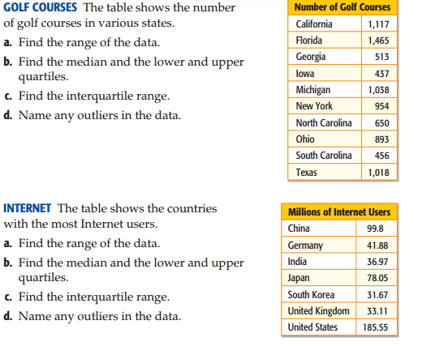
3.

4.

Directions: For the following sets of data, calculate the mean and standard deviation of the data. Describe the mean and standard deviation in words after calculating it.

- The data set below gives the prices (in dollars) of cordless phones at an electronics store.

35, 50, 60, 60, 75, 65, 80

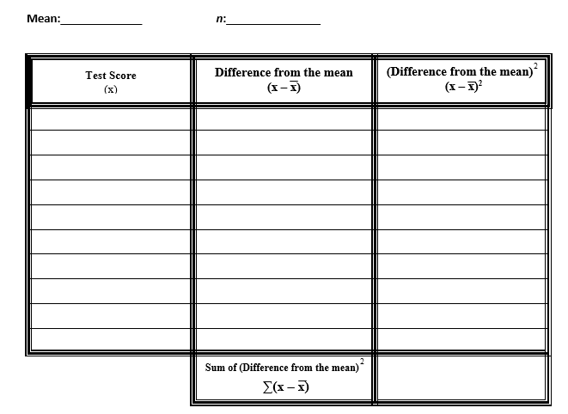

- The data set below gives the numbers of home runs for the 10 batters who hit the most home runs during the 2005 Major League Baseball regular season.

51, 48, 47, 46, 45, 43, 41, 40, 40, 39

