Test Review: Unit 5 Graphing Linear Equations Continued Algebra 1 Kitt
Name:_________________________________________________Date:_____________________Period:________
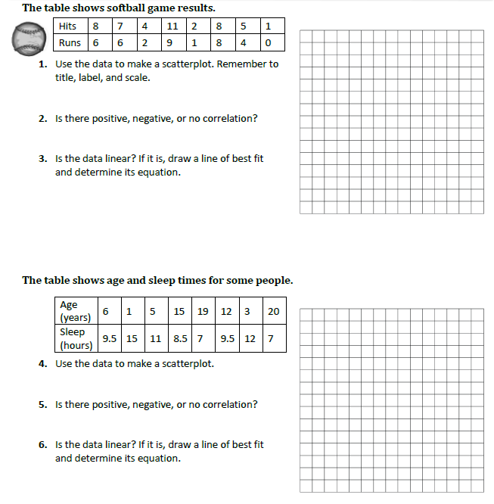
Directions: Rearrange the equation into slope/intercept form $y=mx+b.$ Be sure to reduce all fractions. No decimals or mixed numbers please.
7. $9x+y=12$ 8. $3x-y=15$ 9. $9y=2x+81$ 10. $-4y=-2x+24$

11. $-y=5x-12$ 12. 13. 14.

Directions: Graph the following inequalities.
16. $y≤\frac{4}{3}x+3$ 17. $y>\frac{2}{5}x+1$ 18. $y<2x+5$

m:_________ m:__________ m:__________
b:__________ b:__________ b:__________

Dash or Solid? (circle one) Dash or Solid? (circle one) Dash or Solid? (circle one)
Above or Below? (circle one) Above or below? (circle one) Above or Below? (circle one)

Directions: Graph the following equations in slope/intercept form $y=mx+b$.

19. $2x+8y=8$ 20. -2$x-y=3$ 21. $x=-5$

m:_________ m:__________ m:__________
b:__________ b:__________ b:__________

