Warm Up Unit 5 Linear Equations Continued Algebra 1 Kitt
Name:___________________________________________Date:__________________Period:___

5.1 Solve for y

Directions: Rewrite each equation into slope/intercept form $y=mx+b$

1. 2. 3.

5.2 Graphing Linear Equations

Directions: Rewrite each equation into slope/intercept form $y=mx+b$, Graph your result.

4. $5x+6y=30$ 5. $-4x+3y=12$

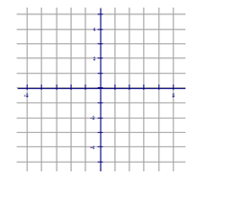

5.3 Graphing Linear Inequalities
Directions: Graph each inequality.
6. $y≤3x+2$ 7. $y>\frac{1}{2}x+3$

M:_____ B:_____ M:_____ B:______
Line: dashed or solid Line: dashed or solid
Shaded: above or below Shadow: above or below

5.4 Scatter Plots and Lines of Best Fit
8. Follow the directions below.
