Homework 1.1 Order of Operations and Evaluating Expressions Algebra 1 Kitt
Name:_____________________________________________________Date:___________________Period:______
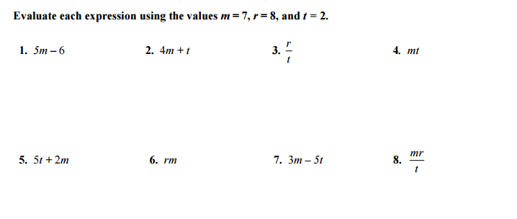
Directions:

Directions: Use Order of operations to evaluate each expression.
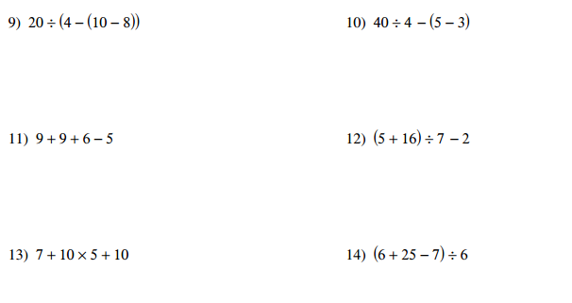

15) $\frac{6+3^{2}}{40÷8}$ 16) $[{(5+2)}^{2}×2+2]÷10$

