WS 2.8 The Quadratic Formula and the Discriminant Algebra 2 Kitt
Name:_____________________________________________________Date:____________________Period:_______
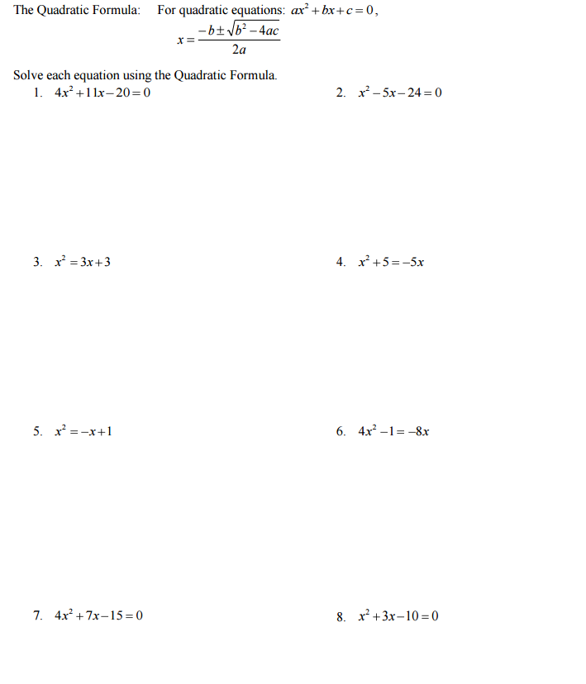

Directions: Find the discriminant of each equation and state the number of real and imaginary solutions.
