Algebra 2 Name ______________
Unit 2 – Test 1 Review Block _______________________________
Quadratic Equations, Functions, and Complex Numbers Date _______________________________

1) Investigate the function: $f\left(x\right)=-{\left(x-2\right)}^{2}+5$
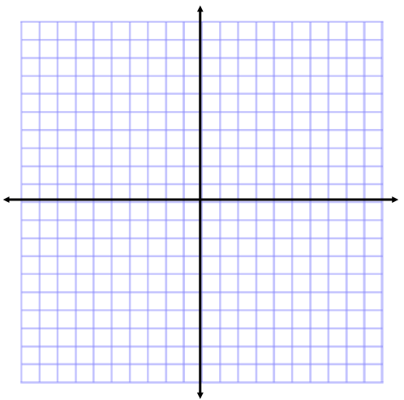
Parent Function: ____________________
Horizontal Shift: ____________________
Vertical Shift: ______________________
Locator Pt (Vertex): _________________
Domain: __________________________
Range: ___________________________
Line of Symmetry: __________________
Opens: Up or Down (circle one)
Compressed or Stretched or Neither (circle)

2) For the function: $f\left(x\right)=3x^{2}-24x+45$, provide the following information, graph, and label as noted. Try using the factoring method. What are the x-intercepts?

a) Line of Symmetry:__________________
b) Vertex: ____________________
c) Y-intercept:_________________
d) Opens up or down (circle one)
e) Stretched, compressed, or neither (circle one)
f) Label the intercepts and vertex on the graph

3) Use the following description to write the quadratic function, $g\left(x\right)$, in vertex form:
The parent function $f\left(x\right)=x^{2}$ has a vertical stretch of 3 and is translated 4 units right, and 3 units down. It opens down.

4) For the function: , provide the following
information, graph, and label as noted. Use Completing the Square to rewrite in vertex form first.
a) Line of Symmetry: ____________________
b) Vertex:__________________
d) Y-intercept:_________________
e) Opens up or down (circle one)
f) Stretched, compressed, or neither (circle one)
g) Label the intercepts and vertex on the graph

5) Find the equation of the function in vertex form
a. f(x) = ____________________ b. f(x) = ______________________
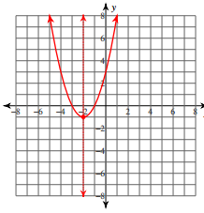
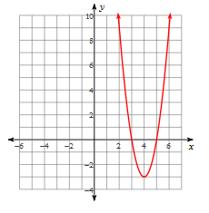

6) For the expression $x^{2}-3x+110$ determine the values of h and k that would satisfy the equation: $x^{2}-3x+110={\left(x-h\right)}^{2}+k$

7) Solve the following system of equations:

$$\left\{\begin{matrix}y=-x+1 \\ y=-x^{2}+4x-3\end{matrix}\right.$$
a. Graph the system of equations.

b. How many solutions does the system have? _____________

c. Estimate the solution(s). Write your answer as an ordered pair.

8) Graph f(x) = x² + 2x -2 using x = -b/2a
Line of Symmetry:
Vertex:
y-int:
Up or down:

8) The height h in feet of a small rocket t seconds after it is launched is given by the equation:
H(t) = -16t² + 128t.
1. How long is the rocket in the air? _________

2. What is the greatest height the rocket reaches? ____

3. About how high is the rocket after 1 second? _______

9) The equation for the cost of manufacturing lawn mowers is C(x) = 0.008x² - 0.04x + 75 where x is the number of lawn mowers manufactured. What number of lawn mowers should be produced to minimize costs?

