**ALGEBRA 2** Name _________________________ Block ____

Unit 4, Test 2 REVIEW

**Shifting from the Parent Graph**

For each equation below, provide the information requested and **SKETCH** the graph (labeling the important point).

1)  a) Locator Point: __________

b) Compressed or Stretched or Neither c) Flipped – Yes or No

c) Domain: ________________ d) Range: _______________

2)  a) Locator Point: __________

b) Compressed or Stretched or Neither c) Flipped – Yes or No

c) Domain: ________________ d) Range: _______________

3) The graph of  is shifted 8 units right and 2 units up. Which is the equation of the translated function? (Circle One)

a)  b)  c)  d) 

4) What are the domain and range of the function ? (Circle One)

a) Domain: $(-∞, ∞)$ Range: $(-∞, ∞)$ b) Domain: $[3, ∞)$ Range: $(-∞,0]$

c) Domain: $\left[3, ∞\right)$ Range: $\left(-∞, ∞\right)$ d) Domain: $\left(-∞, ∞\right)$ Range: $\left[0, -∞\right)$

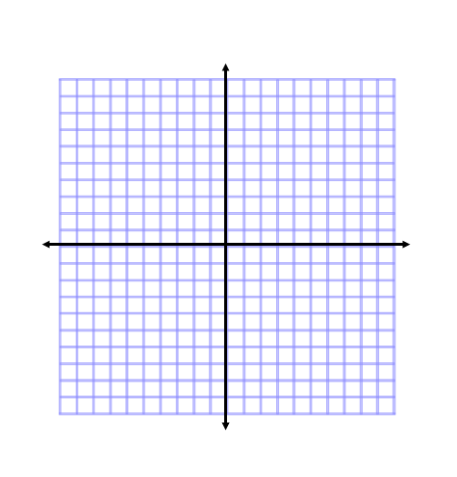**5) Investigate Square Root**  Parent Function:

Locator Point:

Domain:

Range

Compressed or Stretched or Neither? (Circle One)

Flipped – Yes or No? (Circle One)

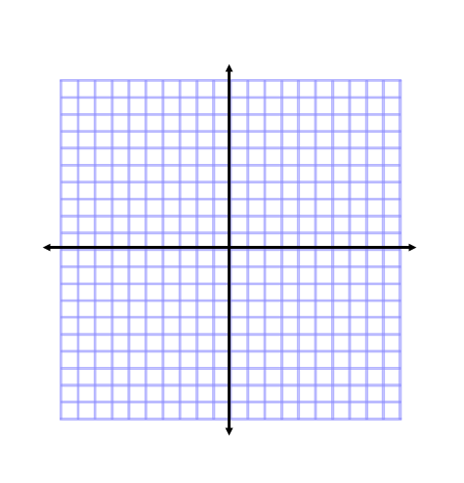**6) Investigate Cube Root $f\left(x\right)=- \sqrt[3]{x}+4$** Parent Function:

Locator Point:

Domain:

Range

Compressed or Stretched or Neither? (Circle One)

Flipped – Yes or No? (Circle One)

1. 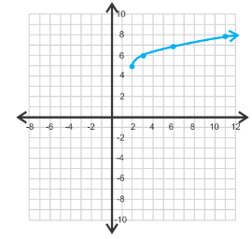Does the graph on the right represent a square root function or a cube root function? Justify your reasoning.

Write the equation of the type of function you chose. Be sure

your graph and equation includes the points given on the graph

to the right.

y = ______________

1. 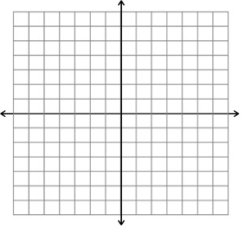On the same grid, graph the functions: $f\left(x\right)=x+1$ and $g\left(x\right)=\sqrt{x+7}$ to find the point of intersection. Label each graph and their intersection point.

Algebraically solve the equation $x+1=\sqrt{x+7}$.

How do your answers compare?

9) Given that and Simplify

a) b) c)

10) Find the inverse of the functions:

a) $f\left(x\right)=\frac{-1}{x+3}$ b) $g\left(x\right)=\sqrt{x}+3$ c) $h\left(x\right)=(x-4)^{2}-15$

**Solving Equations**

11) Solve the equation and check your solutions:

a)  b)  c) 

12) Solve the equation and **check for extraneous roots**:

a) $4\sqrt{x}-1=3$ b) $\sqrt{3x+7}=x-1$ c) 