HW: 3.3 Synthetic Division Algebra 2 Kitt
Name:___________________________________________Date:________________________________Period:______
Directions: Find the quotient using Synthetic Division.
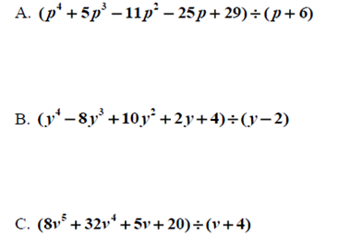

Directions: Completely FACTOR each polynomial given a known factor.
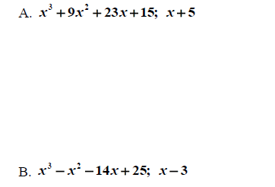

Directions: Use synthetic division to find all the factors of the polynomials. Use the factors to find all the zeros.
