Homework: 4.8 Solving Radical Equations Algebra 2 Kitt
Name:____________________________________________Date:________________________Period:_____
Directions: Solve each equation. Be sure to check your answers for extraneous solutions.
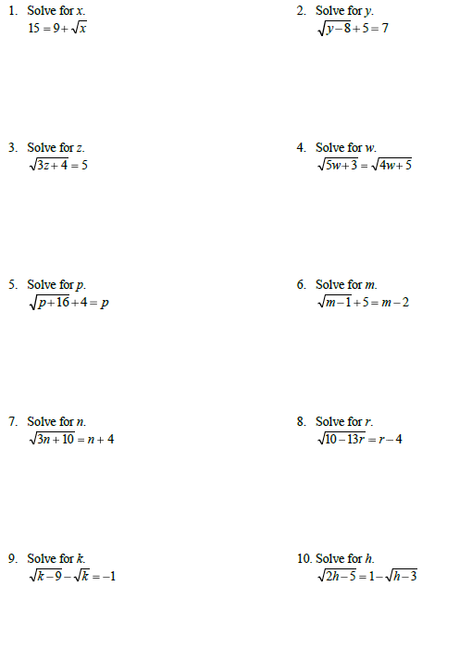
Directions: Solve each equation. Be sure to check your solutions.
11. ${16(x-3)}^{\frac{2}{3}}=64$ 12. ${(x+2)}^{\frac{3}{2}}=1$

13. $-46=-2(33-2m)^{\frac{3}{4}}+8$ 14. $-5(b-20)^{\frac{5}{4}}=-1215$

