Classwork: Unit 4 Radicals, Composition, and Inverse Functions Algebra 2 Kitt

Name:________________________________________Date:__________________________Period:______

**Directions**: Solve each radical function. Check for extraneous solutions.

(1)  (2)  (3) 

(4)  (5)  (6) 

**Directions**: *Let f(x) = 2x – 1, g(x) = 3x, and h(x) = x2 + 1.*

I. *Compute the following:*

7. f(g(x)) 8. f(h(x)) 9. g(h(x))

II. *Determine the inverse and sate whether or not the inverse is a function.*

10. f(x) = 2x – 1, 11. g(x) = 3x, 12. h(x) = x2 + 1

**Directions**: *Graph the following systems of equations and determine the solution.*

13. $\begin{matrix}y=x-4 \\ \\ y=\sqrt{x+2}\end{matrix}$

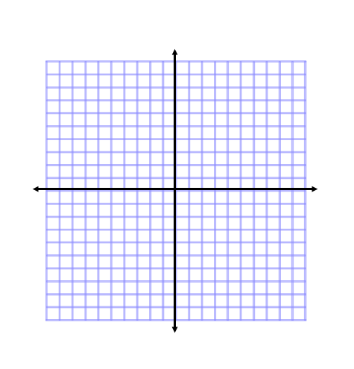14. **Directions**: *Use the function below, label the different parts, and graph.*

 Parent Function:

Locator Point:

Domain:

Range

Compressed or Stretched or Neither? (Circle One)

Flipped – Yes or No? (Circle One)

**Extra Credit**: *Solve the following equation. (Hint: Use factor by grouping).*

