Homework: 1.3 Function Notation & 1.5 Graphing Absolute Value Graphs. Algebra 2 Kitt
Name:__________________________________________ Date:_______________________________Period:_______
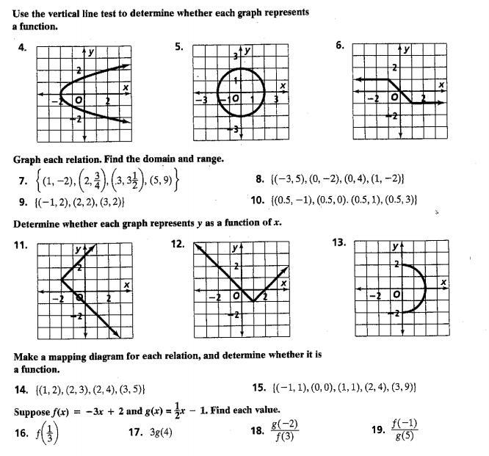

Directions: Graph the following Absolute Value Functions.
