HW 3.2 Relations Algebra 1 Kitt

Name:__________________________________________Date:_________________________________Period:______

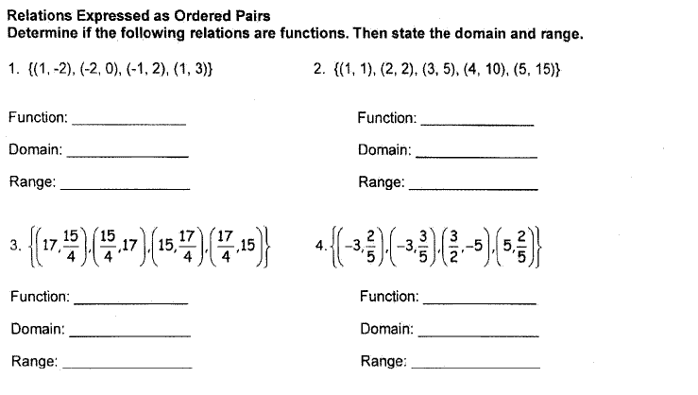

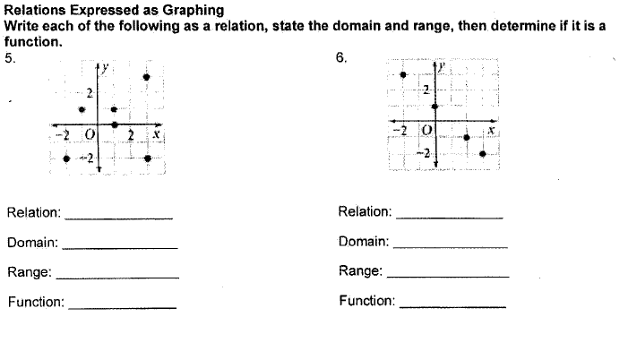

7. Given the relation: $\{\left(-3,2\right),\left(1,4\right),\left(5,5\right),\left(-6,1\right),\left(3,-1\right)\}$,

a. Graph the points.

b. List the quadrants where each point belongs.

8. Using the relation: $\{\left(-3,2\right),\left(1,4\right),\left(5,5\right),\left(-6,1\right),\left(3,-1\right)\}$, state the inverse.

