Homework: 5.3 Solving Logarithms and Natural Logs Algebra 2 Kitt
Name:________________________________________________Date:______________________________Period:________
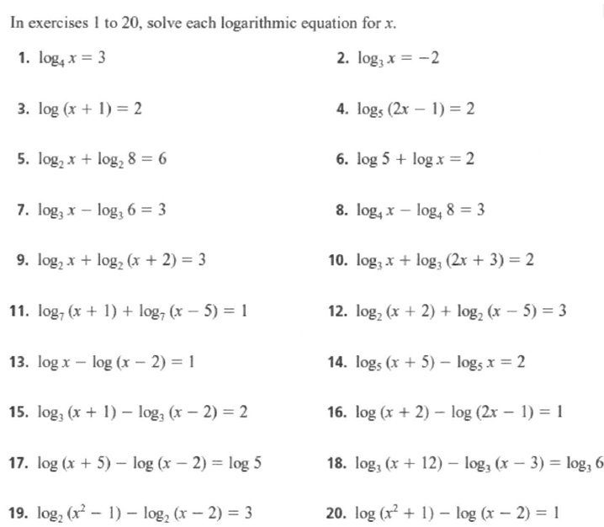

Directions: Solve for x. Round your answer to 3 decimal places.
21. $\ln{x}=3$ 22. $\ln{\frac{1}{x}=2}$ 23. $\ln{x^{2}}=9$ 24. $\ln\left(x-4\right)=-1$

