Worksheet: Exponential and Logarithmic Functions (Extension) Algebra 2 Kitt
Name:________________________________________________________Date:__________________Period:________
Directions: Graph the following functions. Label all the parts below.
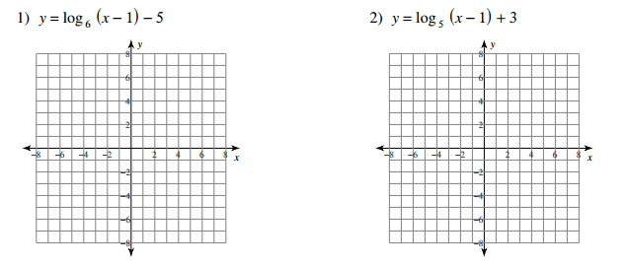
Easy Points: ____________________ Easy Points: ____________________
Shifting: _______________________ Shifting: _______________________
Asymptote: ____________________ Asymptote: ____________________
Domain: _______________________ Domain: _______________________
Range: ________________________ Range: ________________________

3) $y=4^{x+3}-2$ 4) $y={3∙2}^{x}$
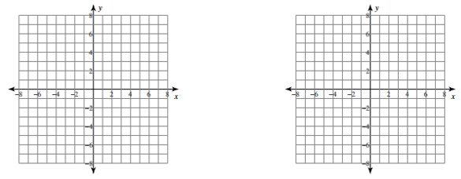
Easy Points: ____________________ Easy Points: ____________________
Shifting: _______________________ Shifting: _______________________
Asymptote: ____________________ Asymptote: ____________________
Domain: _______________________ Domain: _______________________
Range: ________________________ Range: ________________________
Directions: Find the inverse of the following functions.

7) $y=4^{x}+10$ 8) $y=6^{x-1}+4$

Skip #9 and #10.

