**ALGEBRA 2** Name _________________________ Block ____

REVIEW: Unit 3, Test 2 – Polynomial Graphs and Equations:

**The majority of the content on this test is non-calculator, with the exception of #14-17.**

**Factor each polynomial completely**. You **do not** need to solve for x.

1) 2)3)

**Finding Solutions by Factoring**

For each equation below, find all real solutions by factoring and solving for x:

4)  5)  6) 

**Convert each function from factored form to standard form.** Rewrite each polynomial function in standard from.

7) 8) 9)

**Sketching Polynomials**

Sketch the graph of each polynomial to clearly show the end behavior and behavior at each root. **Do NOT** worry about accurately showing the location of the local maximums or minimums.

10) 11) 12)

x-intercepts: ___________

Degree: _______

LC:_________

End Behavior: __________

x-intercepts: ___________

Degree: _______

LC:_________

End Behavior: __________

x-intercepts: __________

Degree: _______

LC:_________

End Behavior: __________

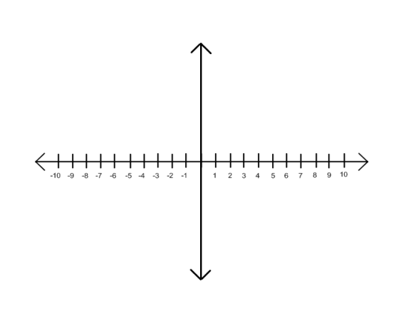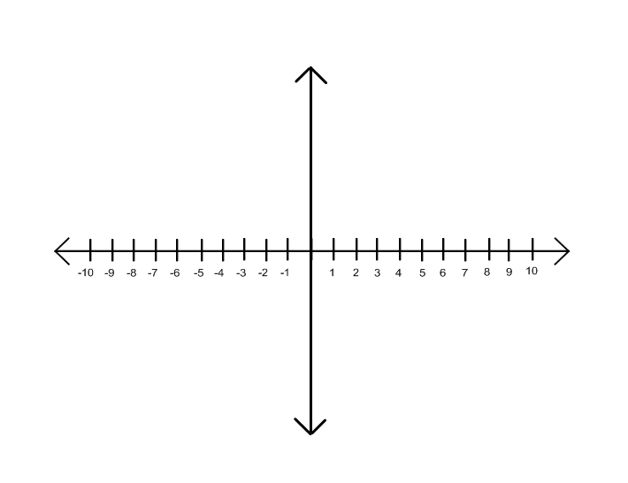

**Knowledge of Polynomial Graphs**

13) Provide the information requested for each polynomial function:

a)  the leading coefficient – positive / negative

b)  end behavior

c)  the x-intercepts

d)  multiplicity for the factor 4

e)  at 3, the graph will cross / bounce / wiggle

f)  the degree – number and odd / even

g)  the y-intercept

h)  the leading coefficient – positive / negative

i)  the degree – number and odd / even

j)  end behavior

14) **Graph the Polynomial**: $f\left(x\right)=-x^{5}-3x^{4}-2x^{3}+x+1$ on a calculator and find the following features.

Degree: ___________

# of Solutions: ___________

Max # of Turning Pts: ___________

Positive or Negative Leading Coefficient? (circle one)

End Behavior: ___________

x-intercepts: ____________________________

y-intercept: ____________________________

Local Maximums: ( _____ , _____ )

Local Minimums: ( _____ , _____ ) , ( _____ , _____ )

Domain: ____________________________

Range: ____________________________

Increasing: ____________________________

Decreasing: ____________________________

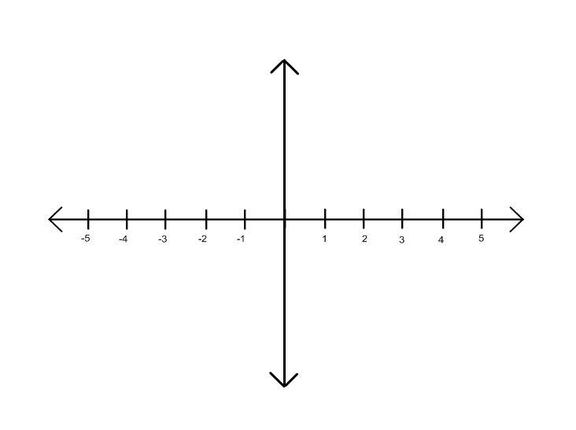

15) Refer to the data table:

1. Show how you can use finite differences to determine the degree of the polynomial that fits the data.

|  |  |  |  |  |  |  |
| --- | --- | --- | --- | --- | --- | --- |
| x | 0 | 1 | 2 | 3 | 4 | 5 |
| y | 2 | 0 | 6 | 56 | 210 | 552 |

1. Use the regression feature of your calculator to write the polynomial function for this relationship.

**Writing Equations**

16) Write a polynomial function *f(x)* of **least degree** that has a leading coefficient of 1, and the given zeros: -2, 5, 3

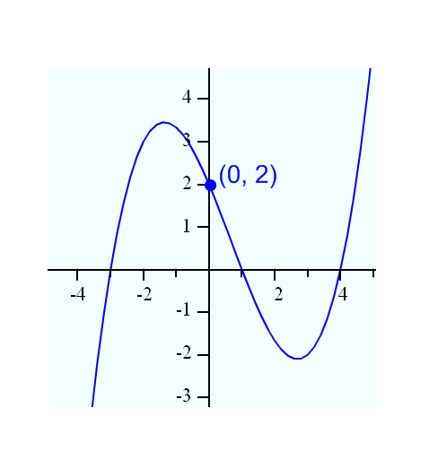17) Write an equation of the following polynomial. Multiply factors to write the equation in **standard form** (don’t forget about *a*).

y = _____________________

18) Write an equation of the following polynomial. You may leave it in **factored form** (don’t forget about *a*).

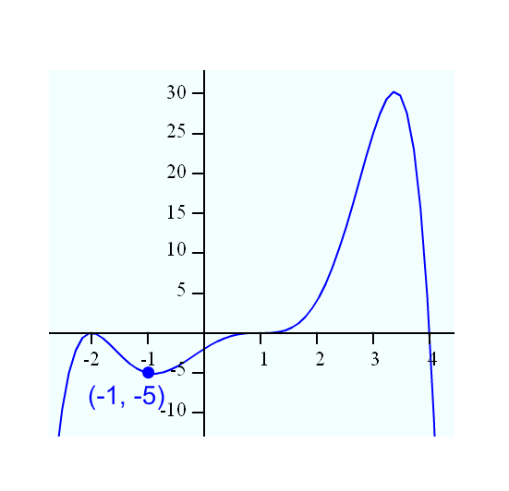

y = _____________________