ALGEBRA 2 Name _________________________ Block ____
Unit 1, Test 2 Review
- Solve the systems of equations by graphing.

- $3x+2y=6$ b) y = 3
$y=\left|x-2\right|-5$ y = 2 |x - 2| - 1

c) $y=-\left|x+3\right|-1$ d) $6x+3y=6$
$y=2x+2$ $2x+y=4$

2) Graph the system of equations on the grid provided using the x and y intercepts.
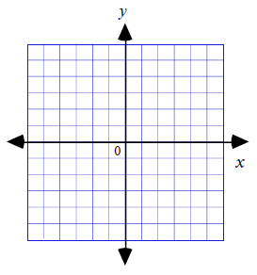
Estimate the solution to this system. $\left\{\begin{matrix}4x-6y=12 \\ 2x+2y=6\end{matrix}\right.$
Estimated Solution: ___________

3) Besides graphing, a system of equations could also be solved by either elimination or substitution. Choose one of these other methods for solving the system of equations in #2 (instead of graphing). Use this method to find the exact solution to the above system.
Exact Solution: ______________

For questions 4-6, set up a system of equations that represents the problem and solve using either substitution
or elimination.

4) A test has twenty questions worth 100 points. The test consists of True/False questions worth 3 points each and multiple choice questions worth 11 points each. How many multiple choice questions are on the test?

5) The school that Stefan goes to is selling tickets to a choral performance. On the first day of ticket sales the school sold 3 senior citizen tickets and 1 child ticket for a total of $30. The school took in $50 on the second day by selling 4 senior citizen tickets and 3 child tickets. Find the price of a senior citizen ticket and the price of a child ticket.

6) The length of Sally’s garden is 4 meters greater than 3 times the width. The perimeter of her garden is 72 meters. What are the dimensions of Sally’s garden? (12 points)

7) Graph the system of inequalities. Shade the region of the graph that makes all equations true.
a) y < 2x – 3 b) y ≥ −5x + 3
$y≥\frac{-2}{3}x-2$ y > −2
x < 4

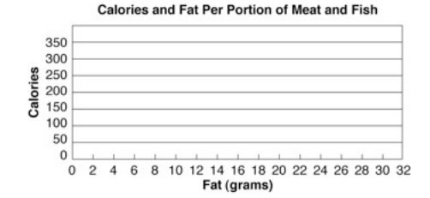
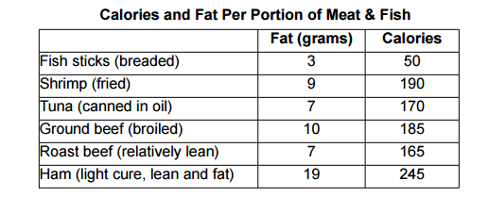
8) This table represents the calories and Fat in grams of meat and fish.
a) Make a scatter plot to represent this data.
b) Draw the line of best fit.
c) Estimate the equation of the line of best fit. Show work below.

d) Use a graphing calculator to find the actual equation of the line of best fit.

e) Use the actual equation of the line of best fit to predict calories of a meat that contains 15 grams of fat. Show work below.

f) Use the actual equation of the line of best fit to determine approximately how many grams of fat are in a meat with 400 calories. Show work below.

9) Solve the following system of equations by elimination:
a) $\left\{\begin{matrix}12x-3y=-9 \\ -4x+y=3\end{matrix}\right.$ b) $\left\{\begin{matrix}5x+5y=5 \\ 5x+3y=4.2\end{matrix}\right.$

10) Solve the following system of equations by substitution:
a) $\left\{\begin{matrix}2x+5y=-5 \\ x+3y=3\end{matrix}\right.$ b) $\left\{\begin{matrix}3x+2y=11 \\ 4x+y=-2\end{matrix}\right.$

11) State the domain and range of the following functions:

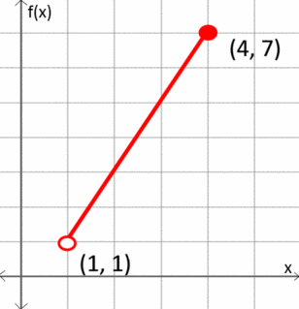
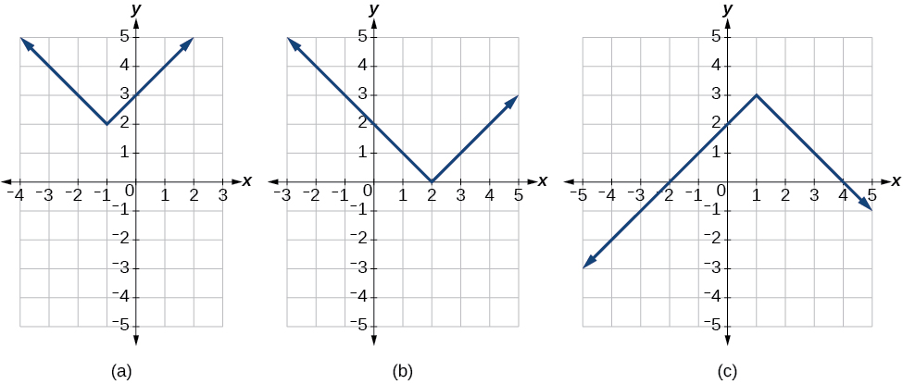 (d)

12) Investigate the function $f\left(x\right)=-\left|x-4\right|+6$.
Parent Function: ____________________
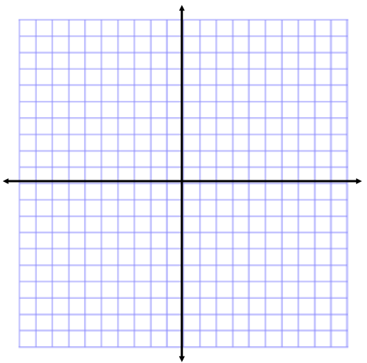
Horizontal Shift: ____________________
Vertical Shift: ______________________
Locator Pt (Vertex): _________________
Domain: __________________________
Range: ___________________________
Line of Symmetry: __________________
Opens: Up or Down
Compressed or Stretched or Neither

