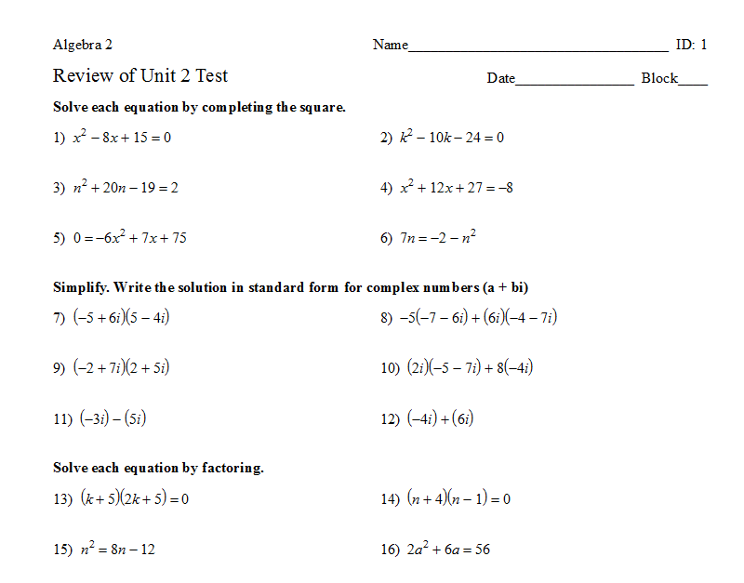

29) For the function: f(x) = 3x² + 6x - 24, provide the following information, graph, and label as noted.

Factor the quadratic in order to get the x-intercepts.

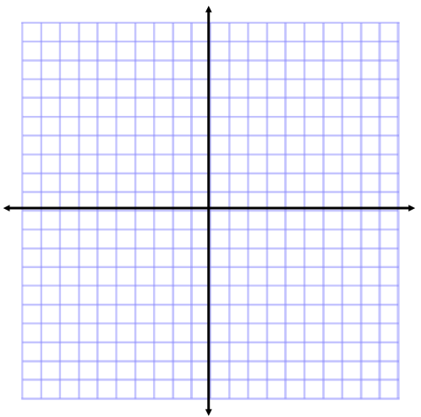
a) X-intercepts: ____________________
b) Line of Symmetry:__________________
c) Vertex: ____________________
d) Y-intercept:__________________
e) Max / Min and Value: ________________
f) Stretched, compressed, or neither (circle one)
g) Label the intercepts and vertex on the graph

30) For the function: f(x) = - 2 (x +1)- 3, provide the following information, graph, and label as noted.
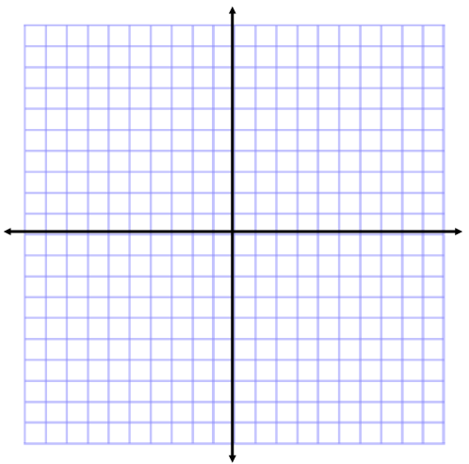

a) Line of Symmetry:__________________
b) Vertex: ____________________
c) Y-intercept:_________________
d) Other points: ________________
e) Max / Min Value: ____________________

f) Stretched, compressed, or neither (circle one)

e) Stretched, compressed, or neither (circle one)

31) For the function: f(x) = ½ (x + 4)(x – 6), provide the following information, graph, and label as noted.

- X-intercepts: __________________________

- Line of Symmetry: _______________________

- Vertex: _____________________________

- Y-intercept: ______________________

- Max / Min Value: _______________________

f) Stretched, compressed, or neither (circle one)

32) Solve the following system:

$$\left\{\begin{matrix}y=3x+1 \\ y=4-x^{2}\end{matrix}\right.$$
  - Graphically:

  - Algebraically:

33)

