Warm Up: Unit 3 Graphs and Functions Algebra I Kitt

Name:_____________________________________________Date:________________________Period:_____

**3.1 The Coordinate Plane**



1. Name the quadrant in which each point is located.
2. (3,-2)

B. (6,2)

C. (-1,-1)

D. (4,-5)

E. (2,0)

1. Graph the points from number 1

**3.2 Relations**

1. State the domain and range of each relation.

A. {(0,-3);(1,4);(1,-3)} B. {(1,5);(2,5);(3,5);(4,5)}

**3.3 Functions**

1. Is the relation {(1,3);(2,4);(3,5);(-1,3);(-2,4);(-3,5)} a function? Why or why not?
2. Given the function, find each value

A.  B. 

6. State whether each graph represents a function or not.

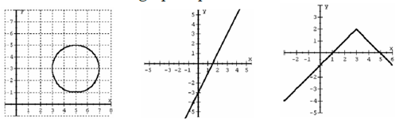

**3.4 Graphing Equations with Tables**

7. Use the domain {-1,0,1,} to find the range given the equation 

****8. Use the domain {-2,-0,2} to find the range given the equation $y=\frac{1}{2}x-3$