Warm Up Unit 6: Rational Expressions Algebra 2 Kitt

Name:_________________________________________________Date:________________________Period:____

**6.1 Graphing Reciprocal Functions**

**Directions**: *Graph the following rational function. Label the different parts.*



$y=\frac{2}{x-3}+1$

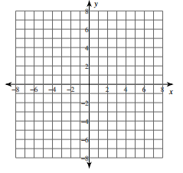

Vertical Asymptote: ___________

Horizontal Asymptote: _________

Domain: ____________________

Range: _____________________

**6.2 Simplifying Rational Expressions**

**Directions:** *Simplify, or find the product or quotient.*

2.  3.

4. 

**6.3 Solving Rational Equations**

**Directions**: *Solve each equation. Check for extraneous solutions.*

4.  5. 